CCNA Beginner Guide: Basic Packet Tracer LAN with Two Switches
PC0, Laptop0, WebServer, Switch0, and Switch1
This guide explains how to build and verify a simple LAN in Cisco Packet Tracer. It uses one PC, one laptop, one web server, and two switches in the same subnet: 192.168.1.0/24.
Important Packet Tracer note: PCs, laptops, and servers are usually configured from Desktop > IP Configuration, not with IOS configuration commands. Their CLI is mainly for testing commands such as ipconfig, ping, arp, and tracert. This guide shows the correct setup steps plus the verification commands you can type.
Topology and Addressing
Device | Port | IPv4 Address | Subnet Mask
PC0 | Fa0 | 192.168.1.51 | 255.255.255.0
Laptop0 | Fa0 | 192.168.1.52 | 255.255.255.0
WebServer | Fa0 | 192.168.1.2 | 255.255.255.0
Switch0 SVI | VLAN 1 (optional mgmt) | 192.168.1.10 | 255.255.255.0
Switch1 SVI | VLAN 1 (optional mgmt) | 192.168.1.11 | 255.255.255.0
All end devices must stay in the same network so they can communicate without a router. Because this is a basic LAN, a default gateway is not required for the pings in this activity.
Logical topology from Packet Tracer
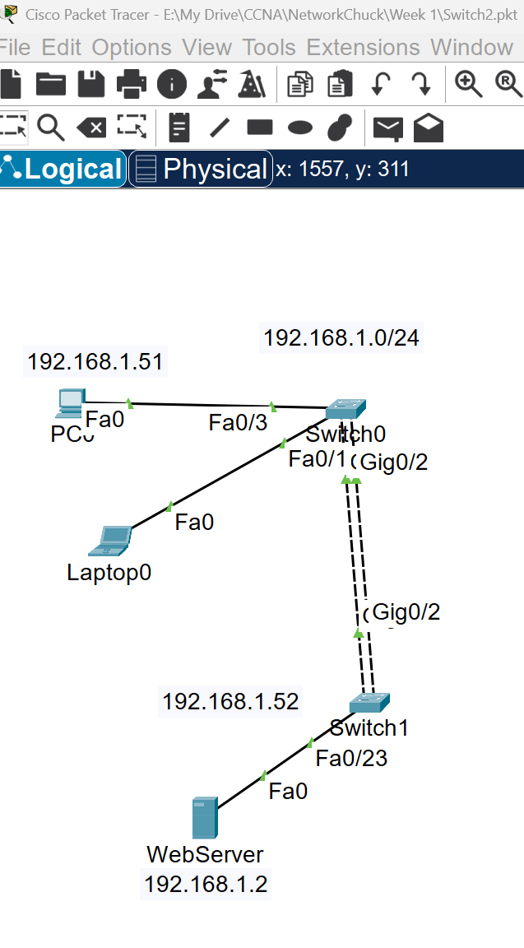
Figure: Logical topology from Packet Tracer
Physical rack view from Packet Tracer
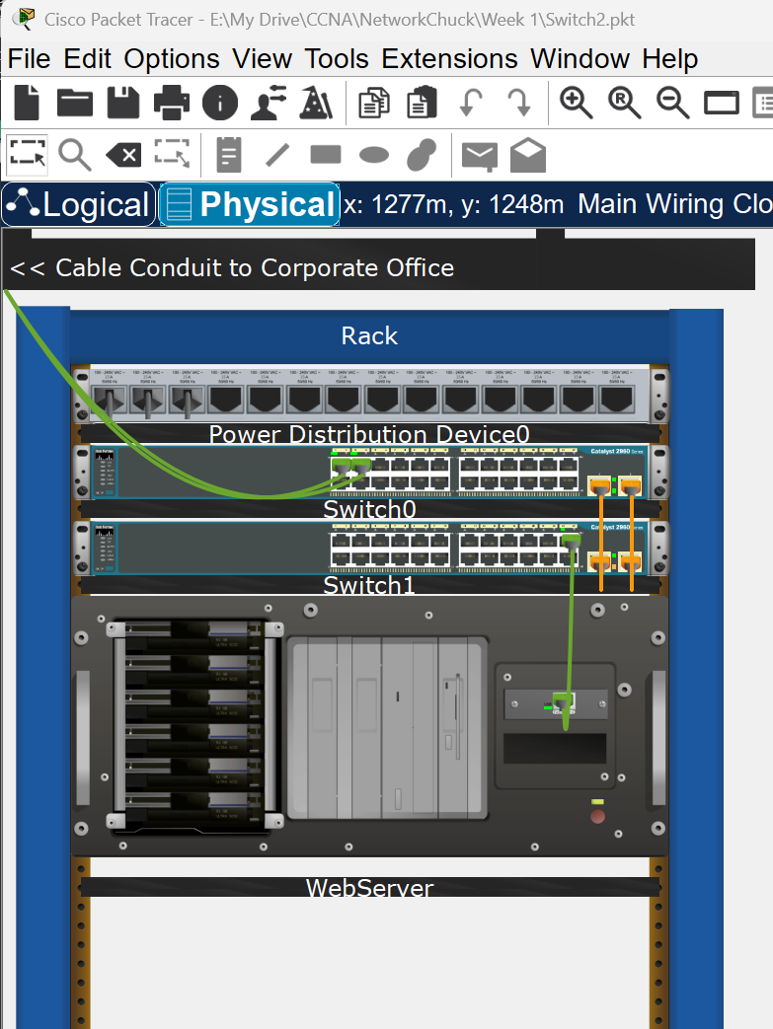
Figure: Physical rack view from Packet Tracer

1. Configure PC0, Laptop0, and WebServer
Use the Desktop tab on each end device to assign the IP address. Then use Command Prompt for verification.
- PC0: open Desktop > IP Configuration and enter IP address 192.168.1.51, subnet mask 255.255.255.0.
- Laptop0: open Desktop > IP Configuration and enter IP address 192.168.1.52, subnet mask 255.255.255.0.
- WebServer: open Desktop > IP Configuration and enter IP address 192.168.1.2, subnet mask 255.255.255.0.
Verification commands on end devices
PC0 Command Prompt
ipconfig
ipconfig /all
Laptop0 Command Prompt
ipconfig
ipconfig /all
WebServer Command Prompt
ipconfig
ipconfig /all
Expected result: each device should show the IP address you assigned and the correct subnet mask.
2. Configure Switch0 and Switch1
The simplest way to make the LAN work is to place all used ports in access mode and use one inter-switch trunk. If you physically connected two switch-to-switch cables, Spanning Tree may block one of them unless you later configure EtherChannel. For a beginner lab, one inter-switch link is enough.
Suggested port use in this guide
Switch | Port | Purpose
Switch0 | Fa0/3 | PC0
Switch0 | Fa0/1 | Laptop0
Switch0 | Gi0/1 | Trunk to Switch1
Switch1 | Fa0/23 | WebServer
Switch1 | Gi0/1 | Trunk to Switch0
Switch0 CLI
enable
configure terminal
hostname Switch0
no ip domain-lookup
interface fa0/1
description Laptop0
switchport mode access
spanning-tree portfast
no shutdown
exit
interface fa0/3
description PC0
switchport mode access
spanning-tree portfast
no shutdown
exit
interface gi0/1
description Link-to-Switch1
switchport mode trunk
no shutdown
exit
interface vlan 1
ip address 192.168.1.10 255.255.255.0
no shutdown
exit
end
copy running-config startup-config
Switch1 CLI
enable
configure terminal
hostname Switch1
no ip domain-lookup
interface fa0/23
description WebServer
switchport mode access
spanning-tree portfast
no shutdown
exit
interface gi0/1
description Link-to-Switch0
switchport mode trunk
no shutdown
exit
interface vlan 1
ip address 192.168.1.11 255.255.255.0
no shutdown
exit
end
copy running-config startup-config
Useful switch verification commands
show ip interface brief
show interfaces trunk
show vlan brief
show mac address-table
show running-config

3. Ping from PC0 to Laptop0
On PC0, open Desktop > Command Prompt and type:
ping 192.168.1.52
Expected result: Reply messages from 192.168.1.52. The first ping may take slightly longer because ARP must resolve the destination MAC address.
4. Ping from PC0 to WebServer
On PC0, type:
ping 192.168.1.2
Expected result: Reply messages from 192.168.1.2. This proves traffic can pass from Switch0 to Switch1 over the inter-switch link.
5. Check MAC addresses
You can check MAC information both on the end devices and on the switches.
On PC0, Laptop0, and WebServer
ipconfig /all
Look for the Physical Address field. That is the NIC MAC address of the device.
On Switch0 and Switch1
show mac address-table
show mac address-table dynamic
Expected result: the switches should learn MAC addresses on the ports where PC0, Laptop0, WebServer, and the inter-switch trunk are connected.
6. Check ARP after ping
After you send the ping tests, use ARP to confirm that PC0 learned the Layer 2 address of the remote devices.
On PC0
arp -a
Expected result: PC0 should list ARP entries for 192.168.1.52 and 192.168.1.2 with their corresponding MAC addresses.
Suggested command sequence on PC0
ipconfig /all
ping 192.168.1.52
ping 192.168.1.2
arp -a
Troubleshooting checklist
- Make sure every end device uses subnet mask 255.255.255.0.
- Check that the switch ports connected to devices are not shutdown.
- Check that the inter-switch link is up on both switches.
- If you used two physical links between switches, one may be blocked by STP. That is normal.
- Verify the cable type and port numbers in Packet Tracer.
Lab success summary
When the lab is complete, PC0 should ping Laptop0 and WebServer successfully, the switches should learn MAC addresses, and PC0 should display ARP entries after the ping tests.

